WPL
Signup Form

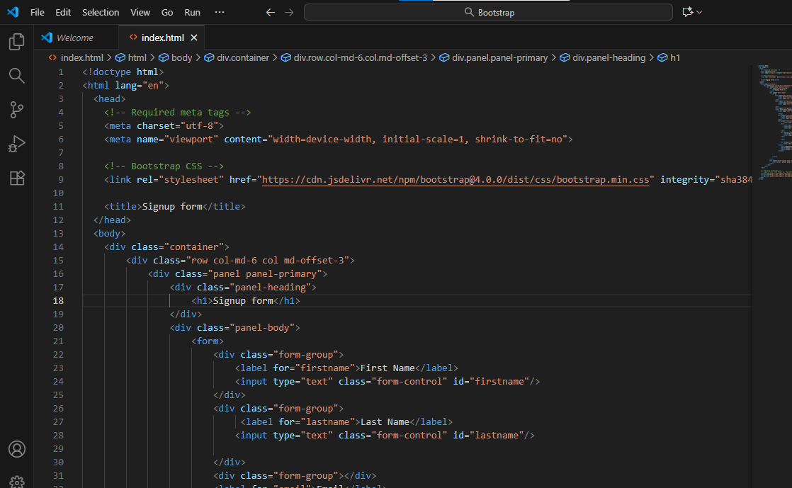

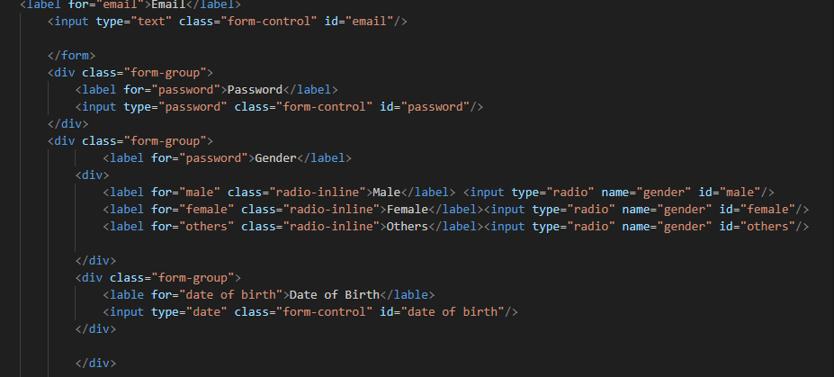

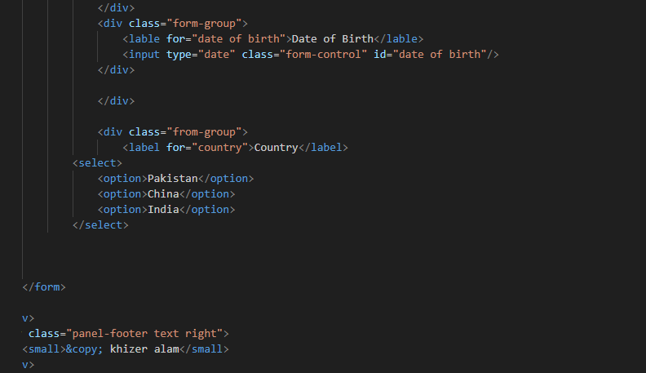
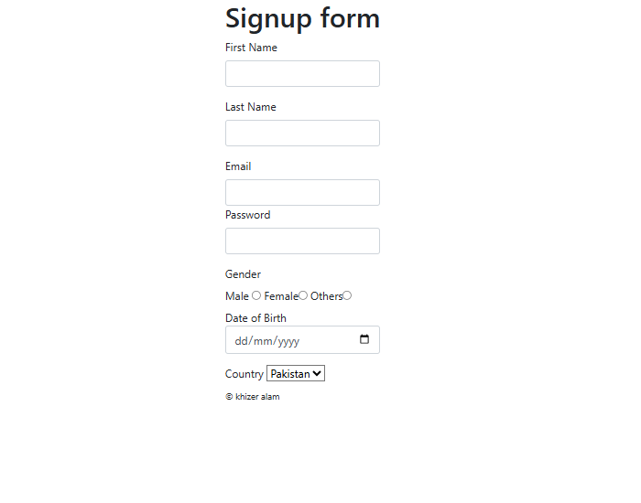

<!doctype html>
<html lang="en">
<head>
<!-- Required meta tags -->
<meta charset="utf-8">
<meta name="viewport" content="width=device-width, initial-scale=1, shrink-to-fit=no">

<!-- Bootstrap CSS -->
<link rel="stylesheet" href="https://cdn.jsdelivr.net/npm/bootstrap@4.0.0/dist/css/bootstrap.min.css" integrity="sha384-Gn5384xqQ1aoWXA+058RXPxPg6fy4IWvTNh0E263XmFcJlSAwiGgFAW/dAiS6JXm" crossorigin="anonymous">

<title>Signup form</title>
</head>
<body>
<div class="container">
<div class="row col-md-6 col md-offset-3">
<div class="panel panel-primary">
<div class="panel-heading">
<h1>Signup form</h1>
</div>
<div class="panel-body">
<form>
<div class="form-group">
<label for="firstname">First Name</label>
<input type="text" class="form-control" id="firstname"/>
</div>
<div class="form-group">
<label for="lastname">Last Name</label>
<input type="text" class="form-control" id="lastname"/>

</div>
<div class="form-group"></div>
<label for="email">Email</label>
<input type="text" class="form-control" id="email"/>

</form>
<div class="form-group">
<label for="password">Password</label>
<input type="password" class="form-control" id="password"/>
</div>
<div class="form-group">
<label for="password">Gender</label>
<div>
<label for="male" class="radio-inline">Male</label> <input type="radio" name="gender" id="male"/>
<label for="female" class="radio-inline">Female</label><input type="radio" name="gender" id="female"/>
<label for="others" class="radio-inline">Others</label><input type="radio" name="gender" id="others"/>

</div>
<div class="form-group">
<lable for="date of birth">Date of Birth</lable>
<input type="date" class="form-control" id="date of birth"/>
</div>

</div>

<div class="from-group">
<label for="country">Country</label>
<select>
<option>Pakistan</option>
<option>China</option>
<option>India</option>
</select>

</form>

</div>
<div class="panel-footer text right">
<small>&copy; khizer alam</small>
</div>
</div>
</div>
</div>

<!-- Optional JavaScript -->
<!-- jQuery first, then Popper.js, then Bootstrap JS -->
<script src="https://code.jquery.com/jquery-3.2.1.slim.min.js" integrity="sha384-KJ3o2DKtIkvYIK3UENzmM7KCkRr/rE9/Qpg6aAZGJwFDMVNA/GpGFF93hXpG5KkN" crossorigin="anonymous"></script>
<script src="https://cdn.jsdelivr.net/npm/popper.js@1.12.9/dist/umd/popper.min.js" integrity="sha384-ApNbgh9B+Y1QKtv3Rn7W3mgPxhU9K/ScQsAP7hUibX39j7fakFPskvXusvfa0b4Q" crossorigin="anonymous"></script>
<script src="https://cdn.jsdelivr.net/npm/bootstrap@4.0.0/dist/js/bootstrap.min.js" integrity="sha384-JZR6Spejh4U02d8jOt6vLEHfe/JQGiRRSQQxSfFWpi1MquVdAyjUar5+76PVCmYl" crossorigin="anonymous"></script>
</body>
</html>

